RIHAM AHAMED ABDUL RAHEEM

HND COMPUTING IDM

Operating System

Contents

**INTRODUCTION TO OS** 1

OS – Operating System 1

**I/O System Management** 3

**Assembler** 3

**Compiler** 3

**Loader** 3

There are two types of operating system 4

List of Operating System in company wise 5

Operating System Requirements 5

Classification of Operating System 6

The Computer OS Architecture and Features 9

1. Layered Architecture 9

2. Monolithic Architecture 10

3. Micro-kernel Architecture 10

4. Distributed Architecture 11

Service Provided by the Operating system 11

**List of figure**

Figure 1: Introduction of Operating System 2

Figure 2: Operating System 4

Figure 3: Layered architecture 9

# **INTRODUCTION TO OS**

## OS – Operating System

An operating system acts as an intermediary between the user of a computer and computer hardware. An operating system is a software that manages the computer hardware. The hardware must provide appropriate mechanisms to ensure the correct operation of the computer system and to prevent user programs from interfering with the proper operation of the system. The purpose of an operating system is to provide an environment in which a user can execute programs in a convenient and efficient manner.

**Operating System –** Definition:

* An operating system is a program that controls the execution of application programs and acts as an interface between the user of a computer and the computer hardware.
* A more common definition is that the operating system is the one program running at all times on the computer (usually called the kernel), with all else being application programs.
* An operating system is concerned with the allocation of resources and services, such as memory, processors, devices, and information. The operating system correspondingly includes programs to manage these resources, such as a traffic controller, a scheduler, memory management module, I/O programs, and a file system.

Operating system performs three functions in a computer

1. **Convenience:** An OS makes a computer more convenient to use.
2. **Efficiency:** An OS allows the computer system resources to be used in an efficient manner.
3. **Ability to Evolve:** An OS should be constructed in such a way as to permit the effective development, testing and introduction of new system functions at the same time without interfering with service

Conceptual view of a computer system

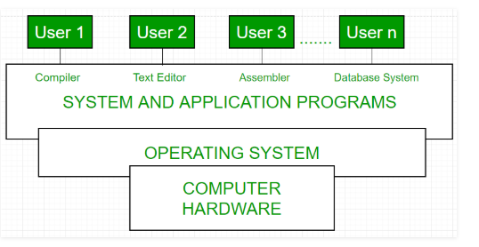

Figure : Introduction of Operating System

Every computer must have an operating system to run other programs. The operating system coordinates the use of the hardware among the various system programs and application programs for various users. It simply provides an environment within which other programs can do useful work.

The operating system is a set of special programs that run on a computer system that allows it to work properly. It performs basic tasks such as recognizing input from the keyboard, keeping track of files and directories on the disk, sending output to the display screen and controlling peripheral devices

**OS is designed to serve two basic purposes:**

1. It controls the allocation and use of the computing System’s resources among the various user and tasks.
2. It provides an interface between the computer hardware and the programmer that simplifies and makes feasible for coding, creation, debugging of application programs.

The Operating system must support the following tasks. The task are:

1. Provides the facilities to create, modification of programs and data files using an editor.
2. Access to the compiler for translating the user program from high level language to machine language.
3. Provide a loader program to move the compiled program code to the computer’s memory for execution.
4. Provide routines that handle the details of I/O programming.

### **I/O System Management**

The module that keeps track of the status of devices is called the I/O traffic controller. Each I/O device has a device handler that resides in a separate process associated with that device.  
The I/O subsystem consists of

* A memory Management component that includes buffering caching and spooling.
* A general device driver interface.

Drivers for specific hardware devices.

**Assembler –**  
The input to an assembler is an assembly language program. The output is an object program plus information that enables the loader to prepare the object program for execution. At one time, the computer programmer had at his disposal a basic machine that interpreted, through hardware, certain fundamental instructions. He would program this computer by writing a series of ones and Zeros (Machine language), place them into the memory of the machine.

**Compiler –**  
The High-level languages- examples are FORTRAN, COBOL, ALGOL and PL/I are processed by compilers and interpreters. A compiler is a program that accepts a source program in a “high-level language “and produces a corresponding object program. An interpreter is a program that appears to execute a source program as if it was machine language. The same name (FORTRAN, COBOL, etc.) is often used to designate both a compiler and its associated language.

**Loader –**  
A Loader is a routine that loads an object program and prepares it for execution. There are various loading schemes: absolute, relocating and direct-linking. In general, the loader must load, relocate and link the object program. The loader is a program that places programs into memory and prepares them for execution. In a simple loading scheme, the assembler outputs the machine language translation of a program on a secondary device and a loader places it in the core. The loader places into memory the machine language version of the user’s program and transfers control to it. Since the loader program is much smaller than the assembler, those make more core available to the user’s program.

## There are two types of operating system

1. Open source operating system

E.g.:

* Linux
* Android
* Ubuntu
* Linux Kernel
* Free BSD
* Fedora
* Net BSD
* Open BSD
* MINIX
* Cent OS
* Kubuntu
* KaiOS

1. License operating system

E.g.:

* Mac OS
* Windows
* Windows Server
* 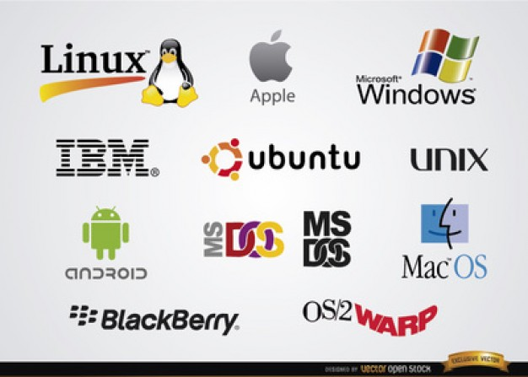LSE/OS

Figure : Operating System

## List of Operating System in company wise

* **Microsoft windows**

1. Windows 1.0
2. Windows 2.0
3. Windows 3.0
4. Windows 95
5. Windows 98
6. Windows XP
7. Windows Vista
8. Windows 7
9. Windows 8
10. Windows 10

* **Mac OS**

1. The Mac OS Classic family
2. The Mac OS X operating system

* **Mobile operating system**

1. Windows Mobile
2. Palms OS
3. BlackBerry OS
4. Symbian OS
5. Android

## Operating System Requirements

**Windows 10**

* 1 GHz or faster processor or SoC processor
* 1 gigabyte (GB) for 32-bit or 2 GB for 64-bit RAM
* 16 GB for 32-bit OS 20 GB for 64-bit OS Hard disk space
* DirectX 9 or later with WDDM 1.0 driver Graphics card

**Windows 7**

* 1 GHz 32-bit (x86) or 64-bit (x64) processor
* 1 GB of system memory
* 16 GB available hard drive space (32-bit), 20 GB available hard drive space (64-bit)
* DirectX 9 graphics device with WDDM 1.0 or higher driver

**Mac OS X Version 10.11 (a.k.a. El Capitan)**

* Compatible Macs:  iMac (Mid 2007 or newer), MacBook (Late 2008 Aluminum, Early 2009, or newer), MacBook Pro (Mid 2007 or newer), MacBook Air (Late 2008 or newer), Mac mini (Early 2009 or newer), Mac Pro (Early 2008 or newer) Xserve (Early 2009)
* Mac OS X Mountain Lion, Lion, or Snow Leopard v10.6.8 already installed
* At least 2GB of RAM
* At least 8.8 GB of disk space available
* At least 2GB of RAM
* At least 8GB of disk space available

**Ubuntu Desktop Edition**

2 GHz dual core processor

1. 4 GiB RAM (system memory)
2. 25 GB of hard-drive space (or USB stick, memory card or external drive)
3. VGA capable of 1024x768 screen resolution

## Classification of Operating System

**i) Multiuser OS:**

In a multiuser OS, more than one user can use the same system at a same time through the multi I/O terminal or through the network. For example: windows, Linux, Mac, etc. A multiuser OS uses timesharing to support multiple users.

**ii)  Multiprocessing OS:**

A multiprocessing OS can support the execution of multiple processes at the same time. It uses multiple number of CPU. It is expensive in cost however; the processing speed will be faster. It is complex in its execution. Operating system like Unix, 64-bit edition of windows, server edition of windows, etc. are multiprocessing.

**iii)  Multiprogramming OS:**

In a multiprogramming OS more than one programs can be used at the same time. It may or may not be multiprocessing. In a single CPU system, multiple program is executed one after another by dividing the CPU into small time slice.

example: Windows, Mac, Linux, etc.

**iv)   Multitasking OS:**

In a multitasking system more than one task can be performed at the same time but they are executed one after another through a single CPU by time sharing. For example: Windows, Linux, Mac, Unix, etc. Multitasking OS are of two types:

a) Preemptive multitasking  
b) Co-operative multitasking  
In the preemptive multitasking, the OS allows CPU times slice to each program. After each time slice, CPU executes another task. Example: Windows XP  
In co-operative multitasking a task can control CPU as long as it requires . However, it will free CPU to execute another program if it doesn’t require CPU. Example: windows 3.x, MultiFinder, etc.

**v)  Multithreading:**

A program in execution is known as process. A process can be further divided into multiple sub-processers. These sub-processers are known as threads. A multi-threading OS can divide process into threads and execute those threads. This increases operating speed but also increases the complexity. For example: Unix, Server edition of Linux and windows.

**vi)  Batch Processing:**

A batch processing is a group of processing system in which all the required input of all the processing task is provided initially. The result of all the task is provided after the completion of all the processing. Its main functions are:

1. Multiple task is processed
2. User cannot provide input in between the processing
3. It is appropriate only when all the inputs are known in advance
4. It requires large memory
5. CPU ideal time is less
6. Printer is the appropriate output device
7. It is old processing technique and rarely used at present

**vii) Online Processing:**

It is an individual processing system in which the task is processed on individual basis as soon as they are provided by the user. It has features like:

1. Individual task is processed at a time
2. User can provide input in between processing
3. It is appropriate when all inputs ate not known in advance
4. It doesn’t require large memory
5. CPU ideal time is more
6. Monitor is appropriate output device
7. It is modern processing technique and mostly used in present

## The Computer OS Architecture and Features

There are four type Computer Operating system architecture.

### Layered Architecture

The layered architecture was introduced as the improvement for its predecessor; Monolithic OS. Each layer can interact with the one just above it and the one just below it.

Lowermost layer which directly deals with the bare hardware is mainly meant to perform the functionality of the Input/output subsystem interaction and the uppermost layer which is the application level acts as an interface between user and operating system.

This is a highly advantageous architecture because all the functionalities are on different layers and hence each layer can be tested and debugged separately.

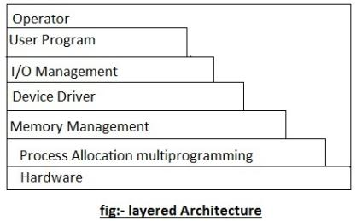

Figure : Layered architecture

**Advantage-** Easier debugging and troubleshooting because all layers are separate, even if one layer stops responding the rest of the operating system can function and adding new layers or removing older layers is very easy.

**Disadvantage-**Non-adjacent layers can’t communicate and dividing functionalities to separate layers is a difficult task and sometimes require a lot of layers.

### Monolithic Architecture

It is the oldest architecture of the operating system. It is solely comprised of one layer, where date & code run in the same layer.

The user mode and kernel mode aren’t strictly separated, so the security is very weak. The kernel can access all the resources present in the system.

In the monolithic systems, each component of the operating system is contained within the kernel.

All the basic services of OS like process management, file management, memory management, exception handling, process communication etc. are all present inside the kernel only.

**Advantage-**Very easy to implement and faster due to direct access to all services.

**Disadvantage -**Making changes to the system are very difficult & security is very weak.

### Micro-kernel Architecture

The basic concept in this architecture is to keep the kernel as small as possible. As the kernel should be the part that should only deal with the most important services, it can be as small as possible.

In the microkernel architecture, only the most important services are put inside the kernel and rest of the OS services are present in the outer level of the kernel.

The user can easily interact with these services outside the kernel.

The micro-kernel is only responsible for: Communication between processes, Memory management & CPU scheduling.

**Advantage:** Expansion of the system is very easy; the security is notably higher than the previous implementation. There are no reasonable disadvantages that serve a significant impact on the system with this architecture.

### Distributed Architecture

A distributed operating system is software that spreads through multiple functioning nodes. These nodes handle tasks through multiple CPUS. Each individual node contains a part of the whole operating system with it. Each node can contain one of the 2 distinct parts.

Either it can be the kernel mode or the user mode supplies the application level interaction. These nodes function as subsets, and subsets as sets to achieve the task of an operating system

The kernel mode of the distributed architecture allows collaboration and maintaining multiple resources and processing functionality thereby producing an efficient and a stable system. This particular process is known as the single system image.

Although we think that the Distributed architecture is one single unit, it is actually sets and sets of nodes.

**Advantage-** Makes it easy for any user to work, decent performance and has wide-range of support.

**Disadvantage -** Low security and a user may request services directly from the kernel itself.

## Service Provided by the Operating system

* The operating system serves several functions:

**Management Processor:**

Operating System Processor manages the distribution among programs using a programming algorithm.

**Management Random Access Memory:**

Operating system manages the memory space allocated for each application and each user, if appropriate. When physical memory is insufficient, the O.S creates an area of memory on the hard drive, called “virtual memory.” Virtual memory permits you to run applications that require a capacity of memory beyond available RAM in the system. However, this memory is much slower.

**Management of input / output:**

Operating system to unify and control access to material resources programs through the drivers (also known as administrators peripheral or input / output).

**Execution Management applications:**

Operating system ensures that applications run smoothly by allocating the resources they need to function. This means that if an application does not respond properly may “succumb”.

**Managing authorities:**

Operating system is responsible for security in connection with the execution of programs by guarantee you that resources are used only for programs and users with appropriate authorization.

**File management:**

The O.S manages all the writing and reading in the file system and access permissions to files and user applications. File system that permits files to be recorded in a tree structure.

**Information management:**

Operating system provides hundreds of indicators that can be used to diagnose the operation of the equipment